HALF SUBTRACTOR

Aim: To perform half subtractor using logicism.

Input:

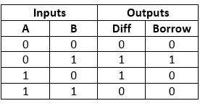

OUTPUT:

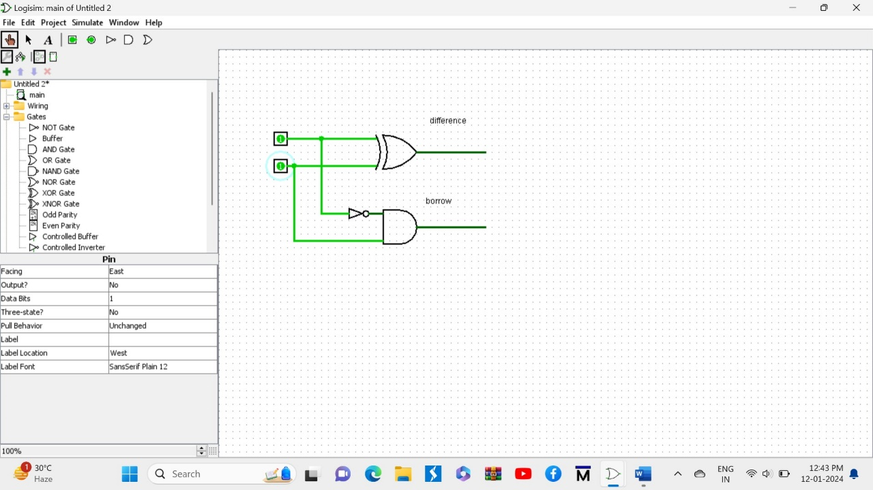

RESULT:

Thus half subtractor is successfully executed through logicism.